Report 1

外媒|| CNN & 路透社：Costco上海开业，顾客爆棚，4 days ago

Costco's first China store was so popular it shut down traffic. But can it keep the buzz going?

By Laura He and Serenitie Wang, CNN Business
August 28, 2019
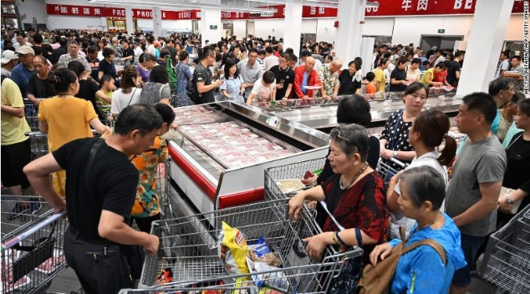
Costco's first store in Shanghai opened to massive crowds on Tuesday.

Hong Kong (CNN Business) Costco has built a cult following in the United States — now it's China's turn. The country's first Costco store is so popular that it had to shut down early on its first day because of too many shoppers.

The retailer opened its first physical outlet in Shanghai on Tuesday morning, and it quickly got too crowded to stay open.

"The store has been clogged up with crowds," Costco said in a text message alert to its members in China. "To provide you with better shopping experience, Costco will suspend business in the afternoon. Please don't come."

Costco's first store in Shanghai opened to massive crowds on Tuesday.

Police were deployed to restore order and manage traffic jams around the store, with law enforcement urging people to remain calm.
"For your safety, we hope citizens who want to go to Costco can maintain a rational attitude about consumption and avoid going out during rush hours. Those who have already gone there, you must follow orders," the Shanghai police said in a statement on its verified account on Chinese social network Weibo.

The photos posted by police with the statement included one of a sign Costco put up outside the store, which read: "The parking lot is full. It takes three hours to wait."

The company even issued an apology on social media for Chinese customers Wednesday, adding that it will put a cap on the number of customers allowed in the store to 2,000 and work with local police to "lessen the disturbance" to its neighbors.

The road ahead

While Costco has had an online presence in China for five years through a partnership with Chinese e-commerce firm Alibaba (BABA), the new brick-and-mortar store in Shanghai marks a significant investment.

Costco's annual membership program, which accounts for the bulk of its profit, is also cheaper in China — it costs 299 yuan ($42) compared to $60 in the United States.

But despite the early buzz around its Shanghai store, the US retailer will have to prove it can stick around for the long haul. It has to contend not only with global rivals like Walmart and big Chinese players like Alibaba and JD.com, but also with China's rapid economic changes and its growing online retail industry.

"There is big market potential for Costco in China, as its value for money strategy is attractive to many middle-class consumers," said Michelle Huang, an analyst at Rabobank in Shanghai.

"Whether Costco can succeed in the long term depends how well it can adapt to China's dynamic retail landscape," she added.

Day One hype

While there are challenges on the horizon, the early hype around China's Costco stores is very real.

Echo Zhou, a 28-year-old financial professional in Shanghai, said she arrived at 9:10 a.m., but didn't make it to the parking lot until an hour later and finally got into the store around 11 a.m.

"The surrounding roads were paralyzed. The highway nearby was also congested," she said.

"By the time I got in, there were crowds of old people who had already wiped out some shelves."

Zhou said she decided to leave without buying anything as there was little room for shoppers inside the store, which was packed with crowds and the big shopping carts.

"I will give it another chance three months later as I've got the membership," she added.

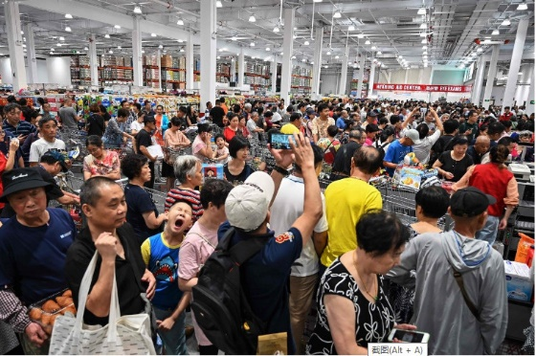

Costco limits shoppers in first China store after opening-day fiasco
John Ruwitch，Reuters
AUGUST 28, 2019

------------------------------------------------------------------------------------------
Report 2

Saturday, September 12, 2020

Costco announces construction of 2nd store in Shanghai
Source: Xinhua| 2020-02-28 16:03:47|Editor: huaxia
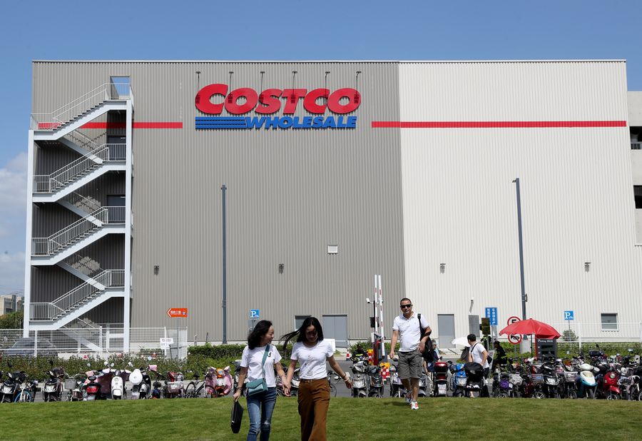
An exterior view of a Costco warehouse store in Minhang District, east China's Shanghai, Sept. 19, 2019. (Xinhua/Liu Ying)

SHANGHAI, Feb. 28 (Xinhua) -- U.S. retail giant Costco announced the start of the construction of its second store on the Chinese mainland on Thursday in Shanghai.

The new store, on a piece of 47,320-square-meter land in Kangqiao, Shanghai's Pudong New Area, will have a floor area of 143,000 square meters to cover an office and a warehouse store, the company said at a ceremony. The store is not far from the Shanghai Disney Resort.

The project has a total investment of 2.6 billion yuan (about 371.2 million U.S. dollars), the company said, adding that the construction work is under full preparation and will soon break ground.

Costco opened its first store on the Chinese mainland last August in Shanghai's Minhang district on the west side of Huangpu River, which has since attracted huge crowds of shoppers. ■

Copyright © 2000-2020 XINHUANET.com All rights reserved.
------------------------------------------------------
Report 3
BIZ / COMPANY
Sam's Club eyes major expansion in China
Ding Yining 19:26 UTC+8, 2020-12-01
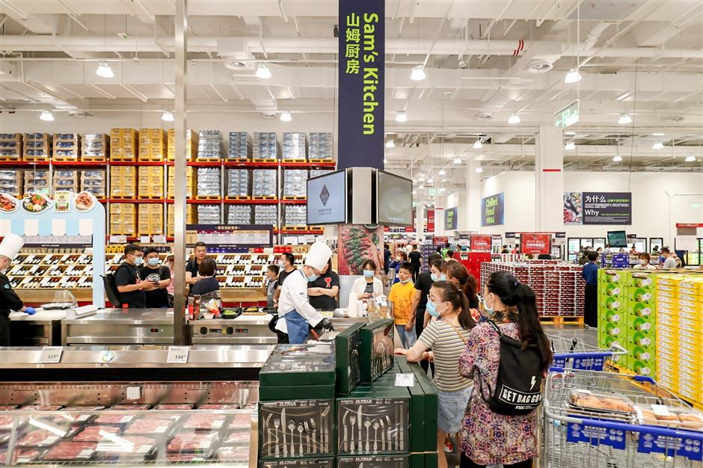
Ti Gong
Sam's Club has 3 million subscribers in China.
Sam’s Club, Walmart’s membership-only warehouse retailer, says it wants to expand in China with up to 45 stores operational or under construction by the end of 2022 or early 2023.

Andrew Miles, president of Sam’s Club China, said: "As shoppers become more open and willing to shop online, we will also grow with that trend.”

The retailer has 3 million subscribers, with 40 percent of them shopping at both online sites and physical stores.

Membership costing 260 yuan (US$39) per year is also eligible for its smartphone app and flagship store on JD as well.

By the end of this year, Sam’s Club will have 31 stores with half a dozen new openings scheduled over the next 12 months.

Its one-hour delivery service was rolled out at all physical stores nationwide earlier this year after a trial operation in 2017.

Miles said a flagship outlet will open in Shanghai next year.
Out of the 4,000-plus items available for its shoppers in China, some 700 private label products contribute to nearly a third of total sales.
Source: SHINE Editor: Wang Yanlin
----------------------------------------------------------

Topic: Business Globalization and Localization

Case Study and Discussions:

Please read three reports above, then do research with your teammates to analyze the problems then present your discussions:

1. What are Costco and Sam’s Club? And their history?
2. Please introduce their business global expansion, strategies and performance?
3. After two-year operation in Shanghai, the second Costco store is almost ready to open in the city soon. For Sam’s Club, it seems more ambitious that “it wants to expand in China with up to 45 stores operational or under construction by the end of 2022 or early 2023.” After searching related information, please discuss the following topics:
1) What are both Costco’s and Sam’s Club’s expansion and adaptation in China recent years? Who is doing better and why?
2) What kind of competitions and challenges they’re facing in China?
3) What coping strategies have they adopted and will consider, when facing fierce competition with their grocery store opponents entered in Shanghai?

